**Chat Application**

**By**

**Bhargav Himmatlal Prajapati(17BCE092)**

**Niral Pateliya (17BCE091)**



**DEPARTMENT OF COMPUTER ENGINEERING**

**Ahmedabad 382481**

**Chat Application**

**Mini Project 1**

Submitted in fulfillment of the requirements

For the degree of

**Bachelor of Technology in Computer Engineering**

By

**Bhargav Himmatlal Prajapati (17BCE092)**

**Niral Pateliya (17BCE091)**

Guided By

**Prof. Kruti Lavingia**

**DEPARTMENT OF COMPUTER ENGINEERING**



**DEPARTMENT OF COMPUTER ENGINEERING**

**Ahmedabad 382481**

**CERTIFICATE**

This is to certify that the Project/Seminar entitled “Chat Application” submitted by Bhargav Himmatlal Prajapati (17BCE092) and Niral Pateliya (17BCE091), towards the partial fulfillment of the requirements for the degree of Bachelor of Technology in Information Technology of Nirma University is the record of work carried out by him/her under my supervision and guidance. In my opinion, the submitted work has reached a level required for being accepted for examination.

Prof. Kruti Rajesh Lavingia Dr. Sanjay Garg

Assistant Professor Professor and Head of Department Department of Computer Science Department of Computer Science, Institute of Technology Institute of Technology,

Nirma University Nirma University,

Ahmedabad Ahmedabad

**ACKNOWLEDGEMENT**

We would like to express our deepest appreciation to all those who provided us the possibility to complete this report. We acknowledge with thanks, the support rendered by Prof. Kruti Rajesh Lavingia, under whose aegis we were able to complete the task in a given period of time. This report could not be complete without coordination of the team members Niral Pateliya and Bhargav Prajapati. We also appreciate the constructive suggestions given by our friends to further enhance content of the report. At the home front, we are extremely grateful to our family members for the support and encouragement, we got from them in successfully completing the report.

**ABSTRACT**

This program aims to facilitate the communication between two users. It provides chatting facility for remote communication between two users.

We aim to have the following functionalities in the program:

* Chat - User can chat with other user.
* Add Friend - User can add his/her friend in friend list.
* Clear Chat - User can clear any friend’s chat.

TABLE OF CONTENTS

Certificate I

Acknowledgment II

Abstract III

Table of Contents IV

1. **Introduction 7**

1.1 Purpose 7

1.2 Product Scope 7

**2. Overall Description 8**

2.1 Product Perspective 8

2.2 Product Functions 8

2.3 Operating Environment 8

2.4 Technology Used 9

**3.** **Interfaces**

3.1 Welcome Page 10

3.2 Sign In Page 11

3.3 Sign Up Page 11

3.4 Forgot Password Page 12

3.5 Friend List Page 13

3.6 Chat Page 14

3.7 Setting Page 15

3.8 Profile Page 16

3.9 About application Page 17

**4. Functions of Application 18**

4.1 Preloading of Application 18

4.1.1 Initial Setup 18 4.1.2 Preloader 18

4.2 SignIn/SignUp Functions 18

4.2.1 Sign In (Login Menu) Function 18

4.2.2 Sign Up Function 19

4.2.3 Add Friend Function 19

4.3 Message Functions 19

4.3.1 Send Message 19

4.3.2 Receive Message 20 4.3.3 Clear Chat Function 20

4.3.4 Sign Out 20

**Chapter 1**

1. **Introduction**

This document describes the requirements of a chat application project. This document consists of purpose, functional requirements and interface of the application, milestones and the use cases of the document.

**1.1** **Purpose**

The purpose of this chat application is to allow users to able to chat with each other. The user can chat with each other. This application is written in java. The GUI is written using swing / JavaFX. To manage the data we will use MySQL with Java Database Connectivity. We will use XMPP protocol for real time messaging in application.

**Chapter 2**

**2. Overall Description**

**2.1 Product Perspective**

This product is built with the perspective of communication between two people. By this product people can easily connect with each other.

**2.2 Product Functions**

The product will provide the following functions:

1. Chat – Chat with another user, using internet user can chat with any user who is used the application.

**2.3 Operating Environment**

2.3.1 Operating System

• Windows 7 or Higher

2.3.2 Software Requirements

• Java 8 or higher

2.3.3 Hardware Requirements

• RAM: 200 MB

• Disk space:

124 MB for JRE;

2 MB for Java Update;

100MB for the Product;

100MB for database.

• Processor: Minimum Pentium 2 266 MHz processor.

• Browsers: Internet Explorer 9 and above, Firefox.

**2.4 Technology Used**

* Basic programming
  + Java Object Oriented Programming
* GUI designing
  + JavaFX and FXML
* Database Management
  + H2 Embedded Database for local database
* Remote Server Database
  + Mysql remote database

**Chapter 3**

**3. Interfaces**

This will deal with the user interface of the application. It describes different pages of the application.

**3.1 Welcome Page**

To welcome the user who is using application first time. This page will give information about application to user and provide button for sign in/ sign up page.

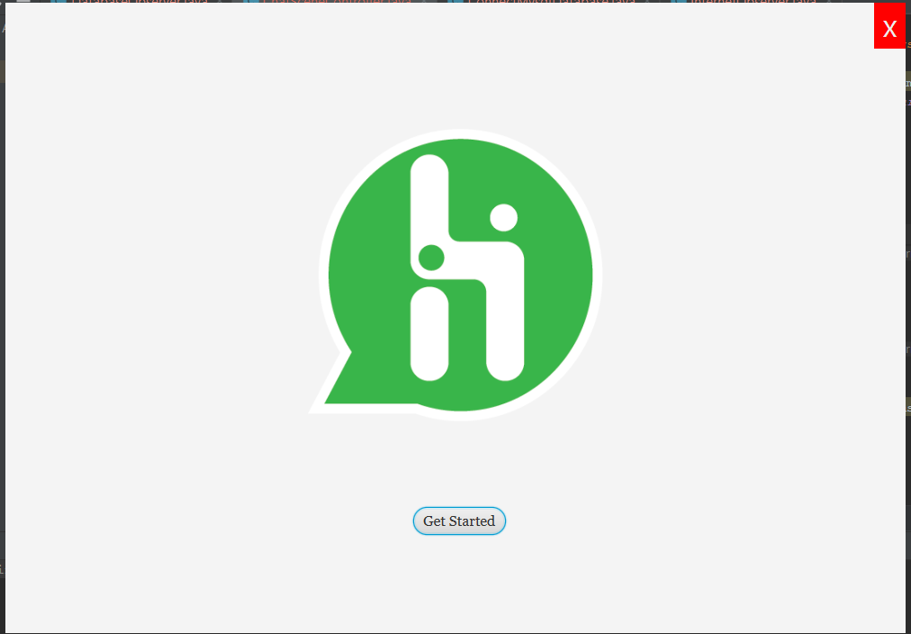

**3.2 Sign In Page**

This page will ask user for username and password for sign in. If user don’t have account this page have button named sign up which will lead him/her to sign up page. This page also have forgot password link, if user forget his/her password he/she can change his/her password by simply answering security question which he/she set during signup.

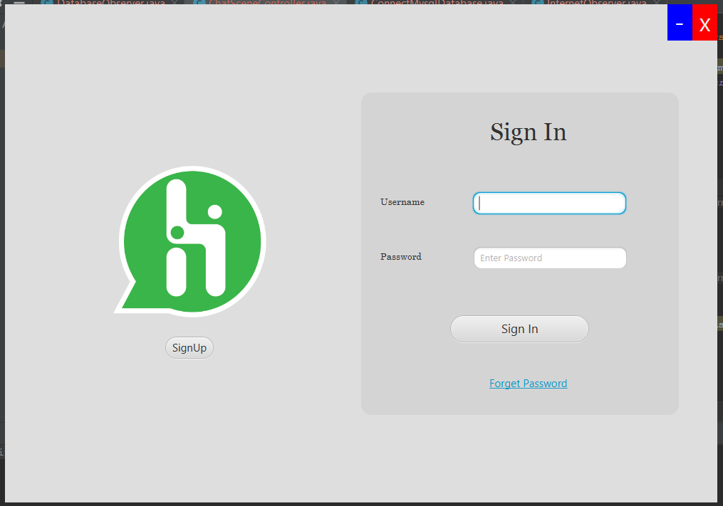

**3.3 Sign Up Page**

In this page application will ask user for some information like name, unique username, Gender, email id, mobile no, password, security question and its answer for create new account.

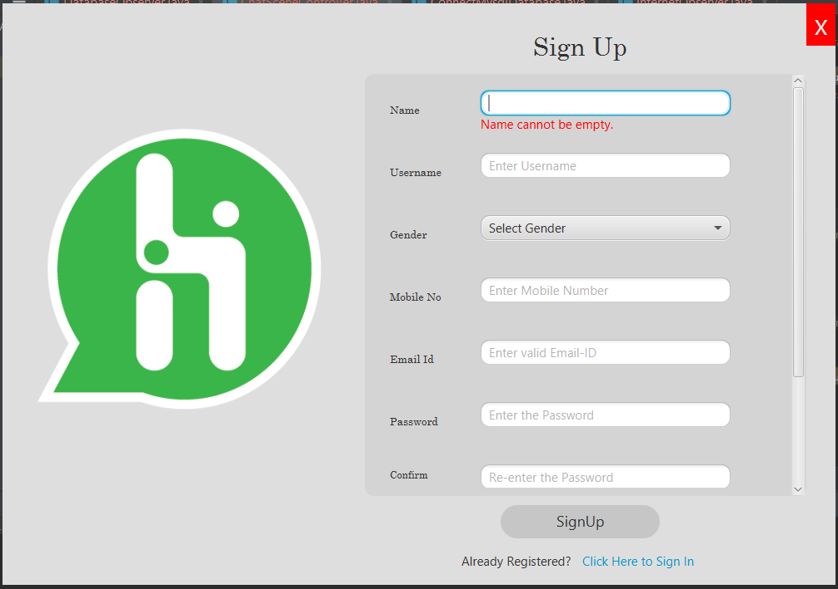

**3.4 Forgot Password Page**

In this page user can change his password by answering security question which is answered by user at time of signup.

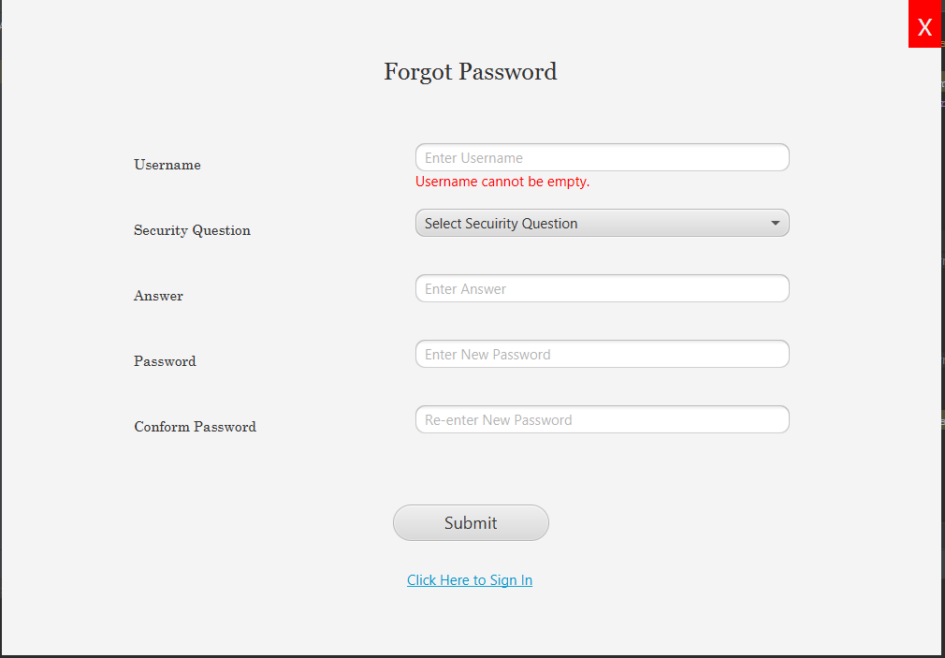

**3.5 Friend List Page**

You can see the list of friends whether you chatted with him/her earlier or not. There is on menu at right top corner for add friend, setting , minimize and close app and for sign out. You can add new friend by entering his/her user id. It bottom there is notification bar with show notification and warnings.

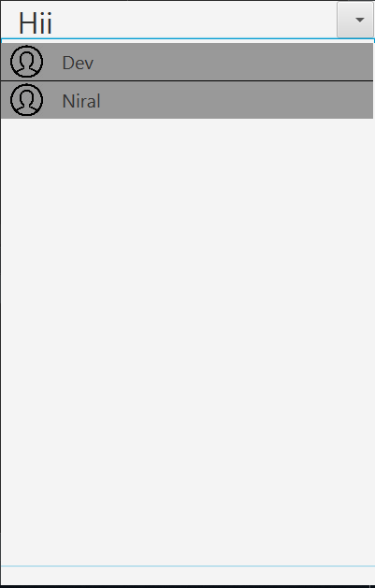

**3.6 Chat Page**

In this page user can chat with his/her friend. In this page, title bar contain friend’s name and in bottom there is text box and send button. In user can type text message and send it by clicking send button. By clicking on friends name we can see his/her profile. There is manu button which contain clear chat option.

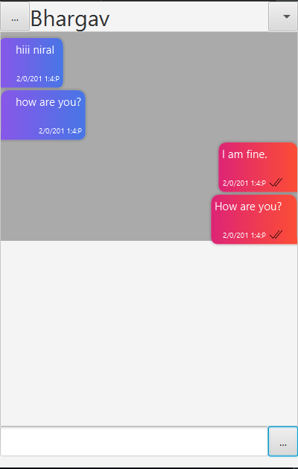

**3.7 Setting Page**

User can move to profile page and one additional option to always set the application at the top of the screen.

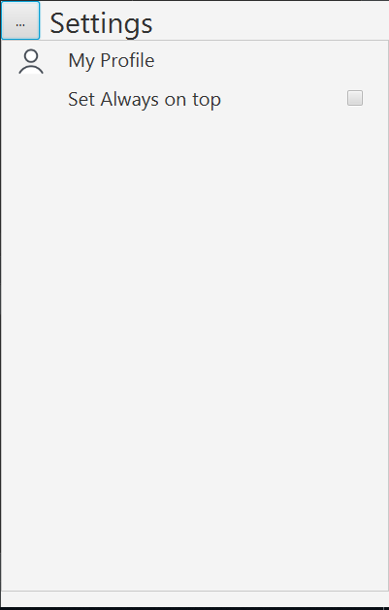

**3.8 Profile Page**

Profile Page contains the detail of user like name, username, Gender, Mobile No, Email Id.

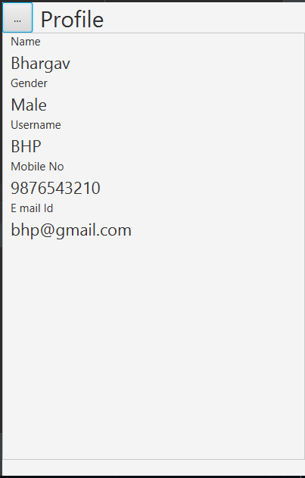

**3.9 About application page**

This page will contain information about application and information about application about developers.

**Chapter 4**

**4 . Functions of chat Application**

**4.1 Preloading Application**

**4.1.1 Init Setup**

At startup app first connect to local database and server.

After that it load all scene from memory and initialize all necessary variable.

After that it check for is user already login or not. if user already login then it show friend list scene. and if user is not login then it shows welcome page.

**4.1.2 Preloader**

When application is busy with init setup at that time preloader is displayed.

If we don’t use preloader then application display after completion of init setup and app will start with delay.

**4.2 Sign in/Sign up Function**

This functional requirement will give option to Sign Up for the chat application or Sign In.

**4.2.1 Sign Up (Login menu function)**

This function will ask user to get name, profile picture, user name, password, etc for create new account.

Here username of one user is unique for every user so it will check whether username is available or not. If it is available it will it will assign to him/her. And then lead to Sign In page.

In back app will enter data of new user into server database and create massage and friend list table for new user.

**4.2.2 Sign In (Login Page function)**

This function will ask client for username and password. It will check whether given username and password matches or not. If it matches then it leads to main page of the application.

In back app enter user data in local database from server and create friend list table and fetch friend list from server. After it create massage table for each friend.

It also create panding massage table in local database.

**4.2.3 Add friend function**

For add new friend user have to enter friends username. app search for this username in database on server.

If app found that username it will add that friend’s detail in friend list table on server and local both. and in local database it create message table for that friend.

**4.3 Message Function**

**4.3.1 Send Message function**

* + This functional requirements will allow the user to send the message to other user.
  + Here, when user send message first this msg uploaded to server database in friends message table and then it added to local database in friends message table and then it added to screen.
  + If internet is not available then message is add to pending message list. and this will send letter when internet available.

**4.3.2 Receive message function**

* For receive message there separate thread is running in background which alway check for new message in user’s message table.
* When new message found it add that message to local database and screen.
* After that it delete that message from server.

**4.3.3 Clear Chat (Message function)**

User can clear chat of selected user his/her stored memory.

**4.3.4 Sign Out (Menu function)**

This function will allow the user to sign out and go back to login menu.

In this function app clear whole local database.